Q4. Understand linux utility commands like ping, arp (Understand each params from ifconfig output)

* ping : A fundamental networking tool used to test connectivity between two devices over a network. It operates using the **ICMP (Internet Control Message Protocol)** and measures how long it takes for a packet to travel from the source to the destination and back.

**Uses of ping Command:**

1. **Check Network Connectivity:**
   * ping google.com checks if the system can reach Google’s servers.
   * If no response is received, there may be a connectivity issue.
2. **Measure Round-Trip Time (RTT):**
   * Displays the time taken for a packet to travel to the destination and back.
   * Useful for diagnosing latency problems.
3. **Determine Packet Loss:**
   * ping shows how many packets were lost during transmission.
   * High packet loss indicates network congestion or hardware issues.
4. **Verify DNS Resolution:**
   * ping can be used with domain names (e.g., ping google.com) to check if DNS resolution is working.
   * If DNS fails, ping will not convert the domain to an IP address.
5. **Continuous Monitoring:**
   * ping -t <IP> (on Windows) or ping <IP> -c <count> (on Linux) keeps sending packets to monitor network stability.
6. **Check Local Network Issues:**
   * ping 127.0.0.1 (localhost) tests if the network stack is functioning.
   * ping <gateway_IP> checks if the system can communicate with the router.
7. **Troubleshoot Specific Network Paths:**
   * ping -I <interface> <IP> allows testing from a specific network interface (useful in multi-network setups).

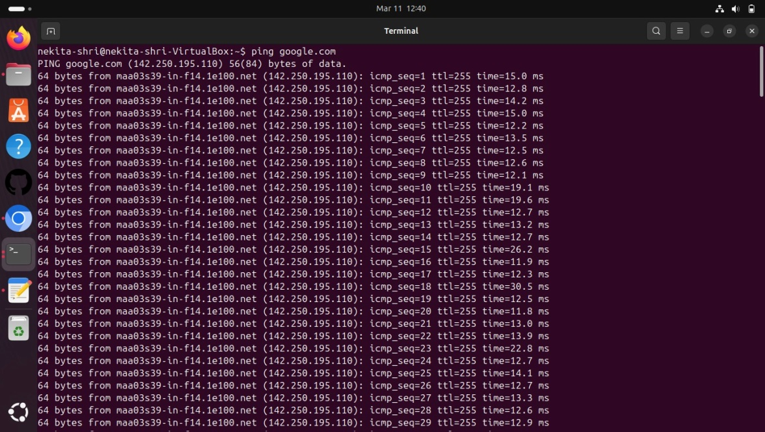

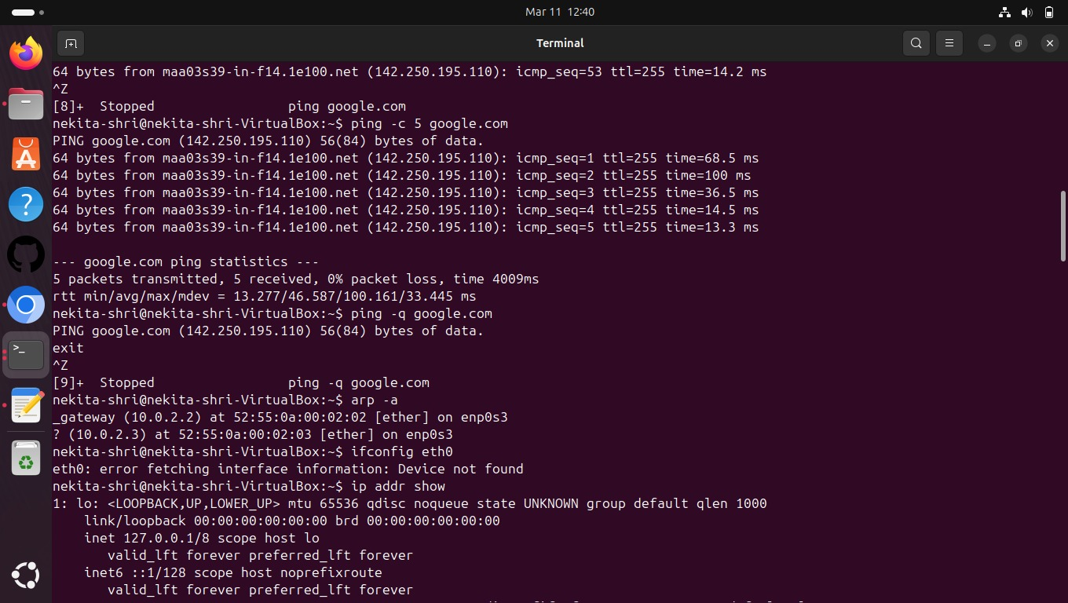

* arp: Used to view and manage the ARP table, which maps IP addresses to MAC (Media Access Control) addresses. It helps in diagnosing network communication issues related to address resolution.

### ****Uses of**** arp ****Command:****

1. **View ARP Table:**
   * arp -a (Windows/Linux/macOS) lists all ARP entries in the system.
   * Displays IP-to-MAC address mappings of devices in the local network.
2. **Add a Static ARP Entry:**
   * arp -s <IP_address> <MAC_address> (Windows)
   * sudo arp -s <IP_address> <MAC_address> (Linux)
   * Manually assigns a MAC address to an IP address (useful for preventing spoofing).
3. **Delete an ARP Entry:**
   * arp -d <IP_address> removes a specific ARP entry.
   * Helps in resolving issues caused by incorrect or outdated ARP mappings.
4. **Flush ARP Cache:**
   * arp -d * (Windows) clears the entire ARP table.
   * sudo ip -s -s neigh flush all (Linux) achieves the same.
   * Used when the system is facing connectivity issues due to outdated ARP records.
5. **Check MAC Address of a Device:**
   * arp -a <IP_address> retrieves the MAC address associated with an IP.

